#### Project II

**"ExamFlex: Exam Cell Automation System"**

Submitted in partial fulfillment of the requirements for the degree of

### Bachelor of Engineering

by

**(Ansari Safiya Nizamuddin Rehana)** Roll No. 12CO02

**(Ansari Uruj Abdul Hadi Rukhsana)** Roll No. 14DCO52 **(Sayyed Tabrez Naushad Ahmed Anisa)** Roll No. 14DCO63 **(Sirkhot Salman Sadique Nazli)** Roll No. 14DCO68

Supervisor

### (Prof. Tabrez Khan)

Co-Supervisor

### (Asst. Prof. Mohammad Salman Shamsi)



**Department of Computer Engineering,**

#### School of Engineering and Technology Anjuman-I-Islam’s Kalsekar Technical Campus

Plot No. 2 3, Sector -16, Near Thana Naka, Khanda Gaon, New Panvel, Navi Mumbai. 410206

#### Academic Year : 2016-2017

**CERTIFICATE**



**Department of Computer Engineering,**

**School of Engineering and Technology, Anjuman-I-Islam’s Kalsekar Technical Campus** Khanda Gaon,New Panvel, Navi Mumbai. 410206

This is to certify that the project entitled ***ËxamFlex: Exam Cell Automation System¨*** is a bonafide work of **Ansari Safiya Nizamuddin Rehana, Ansari Uruj Abdul Hadi Rukhsana, Sayyed Tabrez Naushad Ahmed Anisa, Sirkhot Salman Sadique Nazli** (Roll No.: 12CO02, 14DCO52, 14DCO63, 14DCO68) submitted to the University of Mumbai in partial fulfillment of the requirement for the award of the degree of **Bachelor of Engineering** in **Department of Computer Engineering**.

#### Prof. Tabrez Khan Prof. Javed Sheikh

Supervisor Project Coordinator

#### Prof. Tabrez Khan Dr. Abdul Razak Honnutagi

Head of Department Director

## Project II Approval for Bachelor of Engineering

This project entitled ***ËxamFlex: Exam Cell Automation System¨*** by ***Ansari Safiya Nizamuddin Rehana, Ansari Uruj Abdul Hadi Rukhsana, Sayyed Tabrez Naushad Ahmed Anisa, Sirkhot Salman Sadique Nazli*** is approved for the degree of ***Bachelor of Engineering in Department of Computer Engineering.***

Examiners

1. ..............................

2. ..............................

Supervisors

1. ..............................

2. ..............................

Chairman

.............................

## Declaration

I declare that this written submission represents my ideas in my own words and where others ideas or words have been included, I have adequately cited and referenced the original sources. I also declare that I have adhered to all principles of academic honesty and integrity and have not misrepresented or fabricated or falsified any idea/data/fact/source in my submission. I un- derstand that any violation of the above will be cause for disciplinary action by the Institute and can also evoke penal action from the sources which have thus not been properly cited or from whom proper permission has not been taken when needed.

Ansari Safiya Nizamuddin Rehana Roll Number: 12CO02

Ansari Uruj Abdul Hadi Rukhsana Roll Number: 14DCO52

Sayyed Tabrez Naushad Ahmed Anisa Roll Number: 14DCO63

Sirkhot Salman Sadique Nazli Roll Number: 14DCO68

## Abstract

#### Tittle : ExamFlex - Exam Cell Automation System

The admission or registration process of college is necessary on periodic basis in every educa- tional institution. It should be accurate and less bulky. This manual process of student registra- tion and result generation is always bulky and tedious. All these problems can be eliminated if the college system is automated. By automating this system, the examination coordinators can easily conduct the registration of students and the generation of results systematically. The sys- tem is an efficient, decisive resource for institutions and students. It will help at different levels for bringing reliability, efficiency, scalability, transparency and robust solutions. By automating the college system, the results can be declared in a flexible manner and most importantly it will be error free and student registration, filling of online exam form, revaluation form for respec- tive subjects, filling of KT form, generation of hall tickets and respective results etc. Also the students will be able to check their marks for every practical, oral, term works, unit tests along with the final theory exam mark sheets. So an attempt has been made to make it easy for exam cell staff as well as the students.

Ansari Safiya Nizamuddin Rehana Ansari Uruj Abdul Hadi Rukhsana

Roll No: 12CO02 Roll No: 14DCO52

B.E. (Computer Engineering) B.E. (Computer Engineering)

University of Mumbai. University of Mumbai.

Sayyed Tabrez Naushad Ahmed Anisa Sirkhot Salman Sadique Nazli Roll No: 14DCO63 Roll No: 14DCO68

B.E. (Computer Engineering) B.E. (Computer Engineering)

University of Mumbai. University of Mumbai.

# Contents

Project II Approval for Bachelor of Engineering ii

Declaration iii

Table of Contents vii

List of Figures viii

list of Tables ix

Keywords And Glossary . . . . . . . . . . . . . . . . . . . . . . . . . . . . . . . . x

1. Project Overview 1

1.1 Introduction . . . . . . . . . . . . . . . . . . . . . . . . . . . . . . . . . . . . 1

1.1.1 Motivation . . . . . . . . . . . . . . . . . . . . . . . . . . . . . . . . 1

1.2 Problem Definition . . . . . . . . . . . . . . . . . . . . . . . . . . . . . . . . 2

1.3 Current Systems . . . . . . . . . . . . . . . . . . . . . . . . . . . . . . . . . . 2

* 1. The Problems with Current System . . . . . . . . . . . . . . . . . . . . . . . . 2
     1. Advantages Over Current System . . . . . . . . . . . . . . . . . . . . 2

1.5 Goals and Objectives . . . . . . . . . . . . . . . . . . . . . . . . . . . . . . . 3

1.6 Scope and Applications . . . . . . . . . . . . . . . . . . . . . . . . . . . . . . 3

1. Review Of Literature 4
   1. XamClick Exam Cell Automation System by Harsha Khutafale, Hardika Mate, Vaishnavi Sabnawis, Prof. Nilesh Patil, International Journal of Advanced Re- search in Computer Science and Software Engineering-2016 . . . . . . . . . . 4

2.1.1 Description . . . . . . . . . . . . . . . . . . . . . . . . . . . . . . . . 4

2.1.2 Drawbacks . . . . . . . . . . . . . . . . . . . . . . . . . . . . . . . . 4

2.1.3 Overcoming Drawbacks . . . . . . . . . . . . . . . . . . . . . . . . . 5

* 1. Exam-Cell Automation System: Nevonprojects.com[2] . . . . . . . . . . . . . 6

2.2.1 Description . . . . . . . . . . . . . . . . . . . . . . . . . . . . . . . . 6

2.2.2 Drawbacks . . . . . . . . . . . . . . . . . . . . . . . . . . . . . . . . 6

2.2.3 Overcoming Drawbacks . . . . . . . . . . . . . . . . . . . . . . . . . 6

* 1. Automated Examination Support System by Bondre Rutuja Avinash, Durgi Var- sha Vijaykumar, Mohite Pradnesh Rajeev, Parkar Vishal V, International Journal

of Current Engineering and Technology-2015 . . . . . . . . . . . . . . . . . . 7

2.3.1 Description . . . . . . . . . . . . . . . . . . . . . . . . . . . . . . . . 7

2.3.2 Drawbacks . . . . . . . . . . . . . . . . . . . . . . . . . . . . . . . . 7

2.3.3 Overcoming Drawbacks . . . . . . . . . . . . . . . . . . . . . . . . . 7

2.4 VIVA & KHUSHI . . . . . . . . . . . . . . . . . . . . . . . . . . . . . . . . . 8

2.4.1 Description . . . . . . . . . . . . . . . . . . . . . . . . . . . . . . . . 8

2.4.2 Drawbacks . . . . . . . . . . . . . . . . . . . . . . . . . . . . . . . . 8

2.4.3 Overcoming Drawbacks . . . . . . . . . . . . . . . . . . . . . . . . . 8

* 1. PDF Marksheet Generator, Sanket Mandare, Tyagraj Sonawane, Aman Trivedi,

K. T. V. Reddy, I.J. Information Technology and Computer Science, 2014 . . . 9 2.5.1 Description . . . . . . . . . . . . . . . . . . . . . . . . . . . . . . . . 9 2.5.2 Drawbacks . . . . . . . . . . . . . . . . . . . . . . . . . . . . . . . . 9 2.5.3 Overcoming Drawbacks . . . . . . . . . . . . . . . . . . . . . . . . . 9

* 1. Technological Review 10
     1. PHP 10
     2. MySQL 10
     3. Bootstrap 10
     4. Dia 10

#### Requirement Analysis 12

* 1. Platform Requirement : 12
     1. Supportive Operating Systems : 12
  2. Software Requirement : 12
  3. Hardware Requirement : 14

#### System Design and Architecture 15

* 1. System Architecture 15
  2. Usecase Diagram 16
     1. Usecase Report 17
  3. EER Diagram 18
  4. Data Flow Diagrams 19
     1. Level 0 DFD 19
     2. Level 1 DFD 20
     3. Level 2 DFD 21
  5. Component Diagram 23

#### Methodology 24

* 1. ExamFlex (Exam Cell Automation System) 24
     1. Module 1: Login 25
     2. Module 2: Generation of Exam Form 26
     3. Module 3: Generation of Result 27
     4. Module 4: Generation of Gazette 28
  2. Sequence Diagrams 29
  3. Activity Diagram 31

#### Implementation Details 32

* 1. Assumptions And Dependencies 32
     1. Assumptions 32
     2. Dependencies 32
  2. Implementation Methodologies 32

#### Results and Analysis 33

* 1. Test cases and Result 33
  2. Analytical Discussion 34
     1. System Output 34

#### Conclusion and Future Scope 37

* 1. Conclusion 37
  2. Limitations 37
  3. Future Enhancement 38

#### References 39

#### Appendix A 41

* 1. SGPI/CGPI Calculation 41
  2. Mumbai University Grading System 42
  3. CGPI Equivalent Marks 42

#### Acknowledgment 43

# List of Figures

* 1. XAMPP 12
  2. Web Browser 13
  3. MySQL Logo 13
  4. Computer 14
  5. System Architecture 15
  6. Usecase 16
  7. EER diagram 18
  8. DFD Level 0 19
  9. DFD Level 1 20
  10. DFD Level 2.1 21
  11. DFD Level 2.2 22
  12. Component Diagram 23
  13. Flowchart: Login Process 25
  14. Flowchart for Generation of Exam Form/K.T. Form 26
  15. Flowchart on Generation of Results 27
  16. Flowchart on Generation of Gazette Copies 28
  17. Sequence Diagram 1 29
  18. Sequence Diagram 2 30
  19. Activity Diagram 31
  20. Gazette Output 1 34
  21. Gazette Output 2 35
  22. Gazette Output 3 36
  23. SGPA Formula 41
  24. CGPA Formula 41

# List of Tables

4.1 CGPI Grading System 17

* 1. Letter Grades with respective Grade Points 42
  2. CGPI Grading System 42

## Keywords And Glossary

#### Keywords :

Examination; Exam; Automation; Student; Result; Gazette; Hall Ticket;

#### Glossary :

**A**:

**A** stands for Excellent performance having a Grade Point of 9 with corresponding percentage between 75.00% to 79.99%

An **Automated System** is to automate the manual processes of exam-cell.

**B**:

**B** stands for Very Good performance having a Grade Point of 8 with corresponding percentage between 70% to 74.99%

**C**:

**C** stands for Good performance having a Grade Point of 7 with corresponding percentage be- tween 60.00% to 69.99%

**CGPI** is Cumulative Grade Performance Index which is a type of grading system used by the Mumbai University to grade the students for their overall performance in the Institute.

**D**:

**D** stands for Fair performance having a Grade Point of 6 with corresponding percentage be- tween 50.00% to 59.99%

**Drop** term is used when a student has number of KTs for which a year is held back.

**Database** is the collection of information altogether stored in structured format from where the data(information) about the respective entities can be extracted.

**DFD** stands for Data Flow Diagram, comes under the category of UML diagrams which defines the processes flow at different levels.

**E**:

**E** stands for Average performance having a Grade Point of 5 with corresponding percentage between 45.00% to 49.99%

**External Assessment** are the marks of a student obtained by appearing for a external theory examination.

**F**:

**F** stands for Fail having a Grade Point 0 with corresponding percentage of Less than 40.00%

**G**:

**Gazette** is a special format used by the Mumbai University to accept the records i.e. the results of the students from individual institutes.

**H**:

**Hall-Ticket**, a parchment necessary for appearing for an examination which consists of valid details for the students.

**I**:

**Internal Assessment** are the marks obtained by calculating the marks of the student in the in- ternal tests, the termwork and the attendance record.

**K**:

**K.T.** stands for Keep Term. A student if fails in a particular subject is known as a K.T. where the student doesn’t lose a year for a single subject.

**O**:

**O** stands for Outstanding performance having a Grade Point of 10 with corresponding percent- age of 80.00% and Above

**P**:

**P** stands for Pass performance having a Grade Point of 4 with corresponding percentage be- tween 40.00% to 44.99%

**S**:

**SGPI** is Semester Grade Performance Index which is a type of grading system used by the Mumbai University to measure the performances of the students semester wise.

**U**:

**UML** stands for Unified Modeling Language is a general purpose modeling language used widely in the field of software engineering through which the design of a system can be under- stood thoroughly.

**UseCase** is a Diagram which defines the interactions between external entities and the system.

# Chapter 1 Project Overview

## Introduction

Most of the important processes in the institutes are carried out manually such as the registration of the students, managing huge information about students, faculty members i.e. the teaching and non-teaching staff, managing documents for different entities which leads to enormous bulk of work. This results in poor efficiency, lots of documentation which again leads to unmanage- able data, tedious process and requires a lot of time and human resource.

The main goal of the Exam Cell Automation System is to minimize these workloads and make the Exam Cell process much more convenient to follow. The Exam Cell processes include the managing of student’s academic status distinguished by the year, the departments, the classes as well as with respect to subjects. The Exam Cell process also includes the generation of hall tickets, the generation of exam forms along with the k.t. forms, the generation of results, the generation of gazette copies etc. These all processes are carried out either manually or with the help of some third party software. The use of multiple software for carrying out a process is never considered efficient.

### Motivation

The current examination process system is a complete manual work system which results in tedious work. It is necessary to manage registrations and admissions of students in periodic time at the educational institutes. The current system deals with the manual entries of the in- formation about the students which leads the system prone to errors. The errors which might occur are the loss of data, data redundancy, time consuming process etc.

The current system needs a lot of labour work as all the activities are done manually. The current system not only increases the workload for the exam-cell staff members managing the registration and admission processes but also increases workload for the students. The collec- tion of Results, Mark sheets, Hall tickets becomes a complicated and bulky process. Managing hard copies stack by stack becomes a tedious work for the exam-cell staff.

## Problem Definition

1.2. Problem Definition

This project consists of several modules which are used in the exam cell process. The project represents an automated system which ensures the reduction of the tediousness, more effective work and systematic management. The project deals with the registration of students, the faculty members, generation of automated exam form as well as the k.t. form.

It will also generate the automated results for the students which can be accessed remotely. The project is capable of checking the eligibility of the students i.e. if they’re eligible for the next semester, based on which respective hall tickets will be generated for the students.

## Current Systems

The existing systems implemented in educational institutes are traditional systems in which all the work is done by hand. Some of the systems which generate the Gazettes as per Mumbai University are VIVA[4] and Khushi[5] systems.

## The Problems with Current System

The current systems are traditional systems which support manual processes leading to huge time consumption and stack of hard copies. The systems make the processes delayed and more prone to errors as the work is performed by hand. The systems stated above namely VIVA and Khushi have some limitations. The institutes need to pay huge amount for these systems every year, which then generates the Gazette copies. However, the systems do not provide all the functionality required by the institutes.

### Advantages Over Current System

The system generates the Gazette copies, helps the students to preview their results of their unit tests, their practicals and viva marks, their term work marks before the actual result is displayed. The students will not have to wait for the actual result date to preview these marks.

Chapter 1. Project Overview

## Goals and Objectives

Currently the Exam cell activities includes a lot of manual calculations and are mostly paper based. This makes the process tiresome. This project aims to bring in a centralized system that will ensure the tasks and activities related with the examination can be effectively managed. The system allows the student to register themselves into the system, they can view their academic status on the system. There is no need for the students to stand in long queues for different activities such as the filling of exam form or the k.t. form, the viewing of results etc. The project will provide an easy and efficient way for the processes to be automated which will reduce the workload of the exam cell staff by a heavy extent.

## Scope and Applications

The scope of the project is: All the examination related work for the students can be done using this system. It will provide faster and easier access for updating records as the paper work will reduce. All the students related database can be retrieved at any time by authorized personnel. Application support and maintenance after deployment will be provided to production. The System can be customized as per the requirements of the college.

# Chapter 2 Review Of Literature

## XamClick Exam Cell Automation System by Harsha Khutafale, Hardika Mate, Vaishnavi Sabnawis, Prof. Nilesh Patil, International Journal of Advanced Research in Computer Science and Software Engineering-2016

### Description

Xamclick Exam Cell Automation System[1] is a proposed system published in the International Journal of Advanced Research in Computer Science and Software Engineering-2016. The sys- tem proposes to reduce the manual work which requires extra efforts and extra time to process. The system was proposed by the educational institute ’Rajiv Gandhi Institute of Technology’ to maintain records of the students. The system focuses on presenting information in easy and intelligent manner which provides facilities like online registration, profile creation of students which will lead to reduce the paper work in the institutes.

### Drawbacks

The biggest weakness in this system is the security. The proposed system is prone to security attacks, password cracking which may lead to fabricated data or loss of data. This will result in a very critical condition for the system as well as the institute. The risk of loss of data will force the institute to manage records manually which leads to bulky work, large number of documents, increased workload and the system will become more prone to errors.

Chapter 2. Review Of Literature

### Overcoming Drawbacks

Our system will overcome security problem by automating maximum processes of exam cell. Each and every user will be given specific privileges through which the users will not be able to access any other information. The Faculty members who are responsible for entering the marks into the system will be given privileges for a specific time. They need to submit the marks to the system in the given duration, after which the privileges will be taken from them, making the entries non editable. This will not only increase the security of the system but also the reliability and efficiency of the system.

2.2. Exam-Cell Automation System: Nevonprojects.com[2]

## Exam-Cell Automation System: Nevonprojects.com[2]

### Description

Currently Exam cell activity mostly includes a lot of manual calculations and is mostly paper based. The project aims to bring in a centralized system that will ensure the activities in the context of an examination that can be effectively managed. This system allows students to enroll themselves into the system by registering their names or by sharing details to admin. This is done by providing their personal and all the necessary details like Name, email, examination, semester, etc. The provided details are then entered by admin into the system to create their hall tickets and also creates login id and password for them. After creating the hall ticket, the system mails the link of soft copy to every student who have registered. Students containing link in the mail can view and print the hall ticket and also can login into the system using login id and password to modify or update their details like Phone number, email-id, etc. Admin is also responsible for generation of mark sheets for every registered student. There will be total three to six semesters where each semester contains maximum seven subjects. Admin can enter the marks of every student into their respective mark sheet using the systemâTMs GUI or via Database entry. Every student mark sheet will be created and printed separately. Thus on a whole it serves as a complete automated software which handles the every tedious and complex process handled during the examination times by the exam cell of a college.

### Drawbacks

Accuracy Issues: A computerized system alone does not ensure accuracy, and the warehouse data is only as good as the data entry that created it. As the system is online, the student may fail to receive email or any important notification

### Overcoming Drawbacks

Our system will ensure the security for the users which the above system fails to ensure.

Chapter 2. Review Of Literature

## Automated Examination Support System by Bondre Ru- tuja Avinash, Durgi Varsha Vijaykumar, Mohite Prad- nesh Rajeev, Parkar Vishal V, International Journal of Current Engineering and Technology-2015

### Description

The Automated Examination Support System[3] is a proposed system published in the Inter- national Journal of Current Engineering and Technology. The system deals with the activities related to examination. The system proposes to generate hall tickets, generation of results etc. The system provides different permissions and accessibility rights to different users as per the requirement. The system will produce data for all the users in the system if wanted access to providing no privacy or secrecy. Each user will have his/her working status displayed on the system.

### Drawbacks

Even though the proposed system is related to all the examination processes required by the University of Mumbai, the system doesn’t provide any effort in generating mark sheets as well as generation of gazette copies. The system only deals with calculation of CGPI and SGPI by the use of formulae for conversion of percentage into grade point indices.

### Overcoming Drawbacks

Our system will overcome the drawback of not generating the results by providing a function of Gazette copy generation along with Mark Sheet generation as per the requirement of the University of Mumbai. Our system provides a convenient environment for users by giving them flexibility into the system.

2.4. VIVA & KHUSHI

## VIVA & KHUSHI

### Description

The University of Mumbai suggested two systems for easing the Exam Cell Process. The two systems are VIVA[4] and KHUSHI[5]. VIVA is a software developed by the VIVA College, Virar, Thane. The VIVA software is a gazette generator which takes the data input from the excel sheets and converts it into gazettes by inserting the data in the gazette format provided by the University of Mumbai. KHUSHI is an automated software which processes multiple activities leading to faster and convenient processes in the exam cell. KHUSHI produces analysis reports, generates gazette copies, maintains student history along with different multiple activities.

### Drawbacks

For just the Generation of Gazette copies, VIVA costs around 35000/- INR along with a yearly maintenance of 5000/- to 10000/- INR, a huge amount for a single process. KHUSHI alone costs 150000/- INR, a one time price with maintenance support. The history maintained in this system is in the form of Excel Sheets which can be easily edited by any non authorized person if accessed which is harmful to the institute.

### Overcoming Drawbacks

It is not necessary to pay such huge amount for some processes to be automated. Our system will provide a free trial for a specific period for institutes. Our System will be fixed to low cost for convenient use as the cost price shouldn’t be an issue. Our system will generate the mark sheets along with gazette copies as required by the University of Mumbai. Unlike above software, our system will store data in databases and not in Excel Sheets which is much more secure and difficult to extract. The access to student’s record will be available on just a query to the database. Similarly, changes can be made in the database by the authorised person if required just by throwing a query into the system. The databases will be given privileges and access rights to particular users through which the security of the system will be enhanced.

Chapter 2. Review Of Literature

## PDF Marksheet Generator, Sanket Mandare, Tyagraj Son- awane, Aman Trivedi, K. T. V. Reddy, I.J. Information Technology and Computer Science, 2014

### Description

PDF Mark sheet Generator[6] is a system which generates mark sheet for individual student. The admin of the system enters the marks of each student. That information will be stored in internal collection information database. Percentage and grade is calculated manually. After the marks of all the students is entered by the admin of the system, Gazette is generated and then by clicking the mark sheet generator button. Then application generates the mark sheet of all the students automatically with the grades calculated. Mark sheets will be in PDF format.PDF mark sheets cannot be easily tampered with and require use of complex software. The PDF file of mark sheet of every student will be stored in mark sheet database. And then application makes mark sheets available via Internet on demand.

### Drawbacks

The major drawback of the system is PERCENTAGE and GRADES are calculated MANU- ALLY. It increases the workload of the staff and as it is processed manually there are chances of making mistakes. A lot of time is consumed in performing calculations. The system is per- forming only two functions that is generating Gazettes and then the Mark sheet of individual student.

### Overcoming Drawbacks

Our proposed system calculates percentage and grades automatically and not manually, which eliminates the chance of any mistakes or errors. In addition to this, it provides various different functions for ease to Exam Cell Staff, Head of the Department, Faculties and Students. All the details are stored in the database so it can be easily retrieved by the exam cell for checking or updating the details. Gazette is generated automatically, no extra time or efforts of the Exam Cell staff are required to list out the students who have cleared the semester or the students with A.T.K.T.

2.6. Technological Review

## Technological Review

### PHP

PHP is a server-side scripting language designed primarily for web development but also used as a general-purpose programming language. Originally created by Rasmus Lerdorf in 1994, the PHP reference implementation is now produced by The PHP Development Team. PHP originally stood for Personal Home Page, but it now stands for the recursive acronym PHP: Hypertext Preprocessor.

### MySQL

MySQL is an open-source relational database management system (RDBMS). Its name is a combination of "My", the name of co-founder Michael Widenius’ daughter, and "SQL", the abbreviation for Structured Query Language. The MySQL development project has made its source code available under the terms of the GNU General Public License, as well as under a variety of proprietary agreements. MySQL was owned and sponsored by a single for-profit firm, the Swedish company MySQL AB, now owned by Oracle Corporation. For proprietary use, several paid editions are available, and offer additional functionality.

### Bootstrap

Bootstrap is a free and open-source front-end web framework for designing websites and web applications. It contains HTML- and CSS-based design templates for typography, forms, but- tons, navigation and other interface components, as well as optional JavaScript extensions. Un- like many web frameworks, it concerns itself with front-end development only. Bootstrap is the second most-starred project on GitHub, with more than 107,000 stars and 48,000 forks.

### Dia

Dia has a modular design with several shape packages available for different needs: flowchart, network diagrams, circuit diagrams, and more. It does not restrict symbols and connectors from various categories from being placed together. Dia has special objects to help draw entity- relationship models (obsoleted tedia2sql or newer parsediasql can be used to create the SQL DDL), Unified Modeling Language (UML) diagrams, flowcharts, network diagrams, and simple electrical circuits. It is also possible to add support for new shapes by writing simple XML files, using a subset of Scalable Vector Graphics (SVG) to draw the shape.

Chapter 2. Review Of Literature

Dia loads and saves diagrams in a custom XML format which is, by default, gzipped to save space. It can print large diagrams spanning multiple pages and can also be scripted using the Python programming language.

# Chapter 3 Requirement Analysis

## Platform Requirement :

### Supportive Operating Systems :

The supported Operating Systems for client include: Linux, Windows, Mac OS

## Software Requirement :

The Software Requirements in this project include:

#### XAMPP:

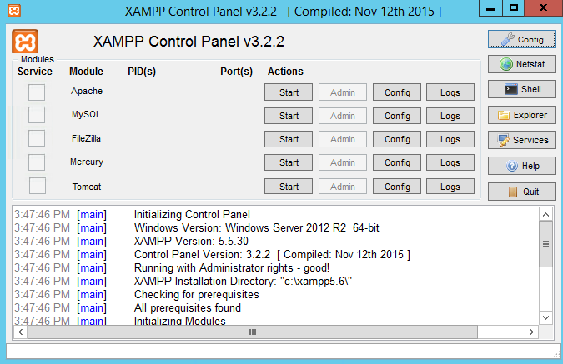

Figure 3.1: XAMPP

Chapter 3. Requirement Analysis

XAMPP is a free and open source cross-platform web server solution stack package developed by Apache Friends, consisting mainly of the Apache HTTP Server, MariaDB database, and interpreters for scripts written in the PHP and Perl programming languages.

#### Web Browser:



Figure 3.2: Web Browser

A web browser (commonly referred to as a browser) is a software application for retrieving, presenting and traversing information resources on the World Wide Web.

#### MySQL:



Figure 3.3: MySQL Logo

MySQL is an open-source relational database management system (RDBMS). Its name is a combination of "My", the name of co-founder Michael Widenius’ daughter, and "SQL", the abbreviation for Structured Query Language.

3.3. Hardware Requirement :

## Hardware Requirement :

#### Computer(Device):

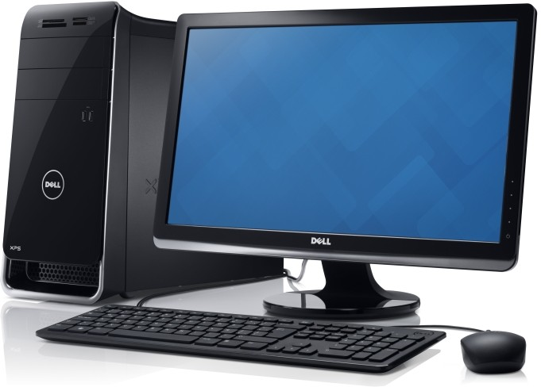

Figure 3.4: Computer

A computer or a device is needed to run the developed system.

#### RAM:

RAM should be above 2 GB.

#### Processor:

32 bit/ 64 bit processors are supported.

# Chapter 4

**System Design and Architecture**

## System Architecture

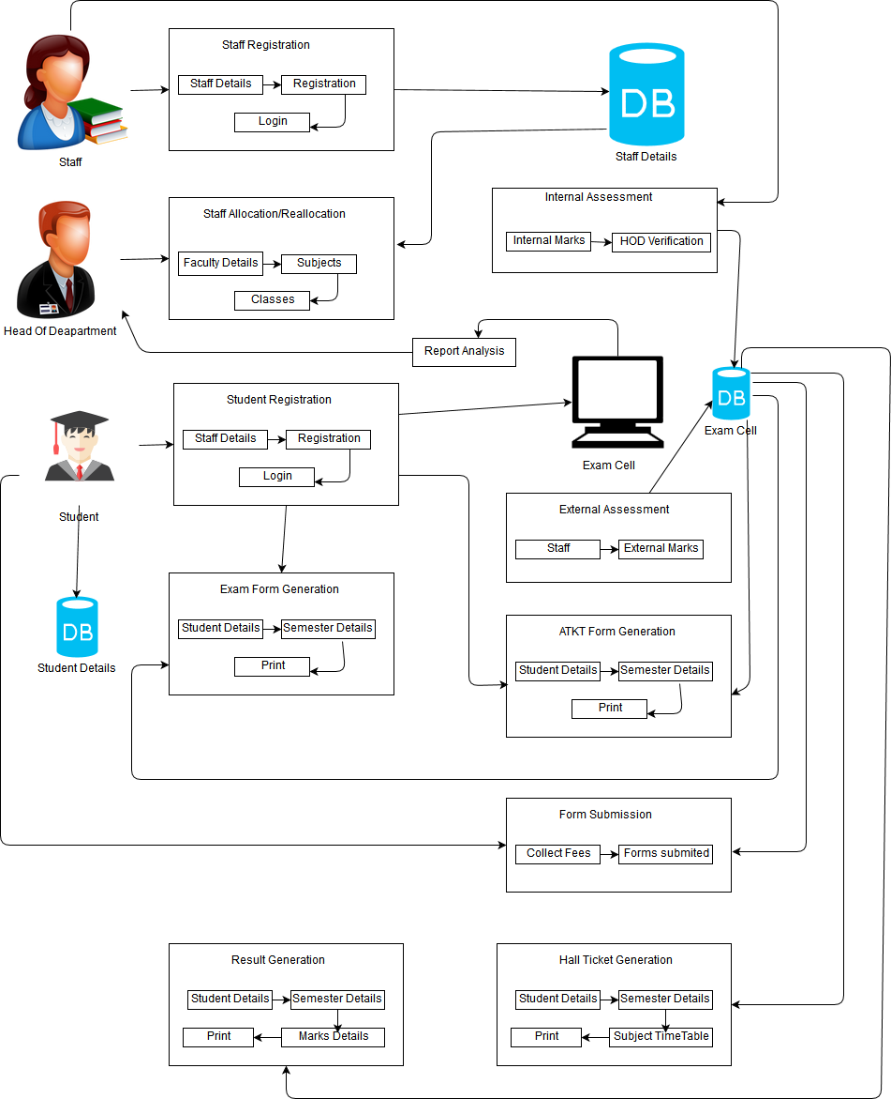

Figure 4.1: System Architecture

## Usecase Diagram

* 1. Usecase Diagram

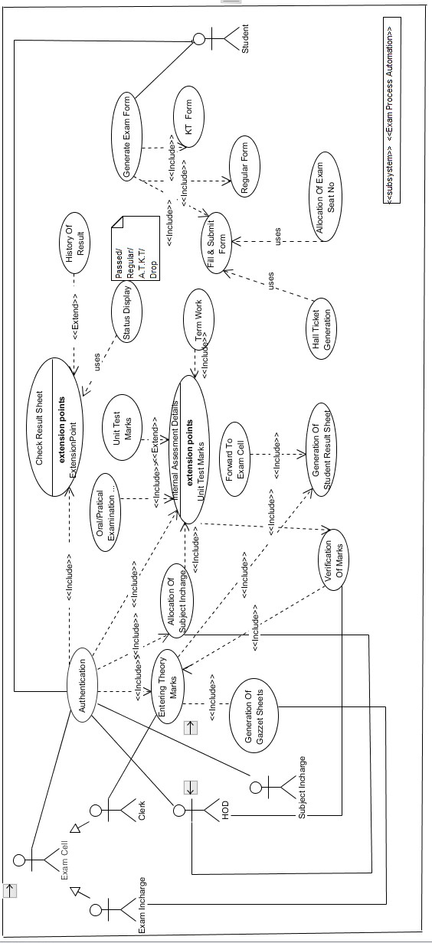

Figure 4.2: Usecase

Chapter 4. System Design and Architecture

### Usecase Report

|  |  |
| --- | --- |
| Title | Exam cell Process Automation |
| Description | ExamCell Process Automation is website  which automates a number of exam process. Each User has their own account with which he/she can easily perform his/her tasks. The faculty can maintain the student marks details for each class in more organized way. Students can view their results and important links and the workload of exam cell co-ordinator reduces. The generation of gazette becomes easy and fast. |
| Primary Actor | Exam Cell Co ordinator, Teaching faculty and  Students |
| Pre-condition | Must have a login ID to get access to website. |
| Post-condition | Students will get to view the Result. |
| Main | Generation of Gazette. |
| Success Scenario | Fetching Marks details from the faculty and  generating gazettes. |
| Frequency of use | Anytime. Mainly during examinations. |
| System Requirement | Web Browser. |

Table 4.1: CGPI Grading System

## EER Diagram

* 1. EER Diagram

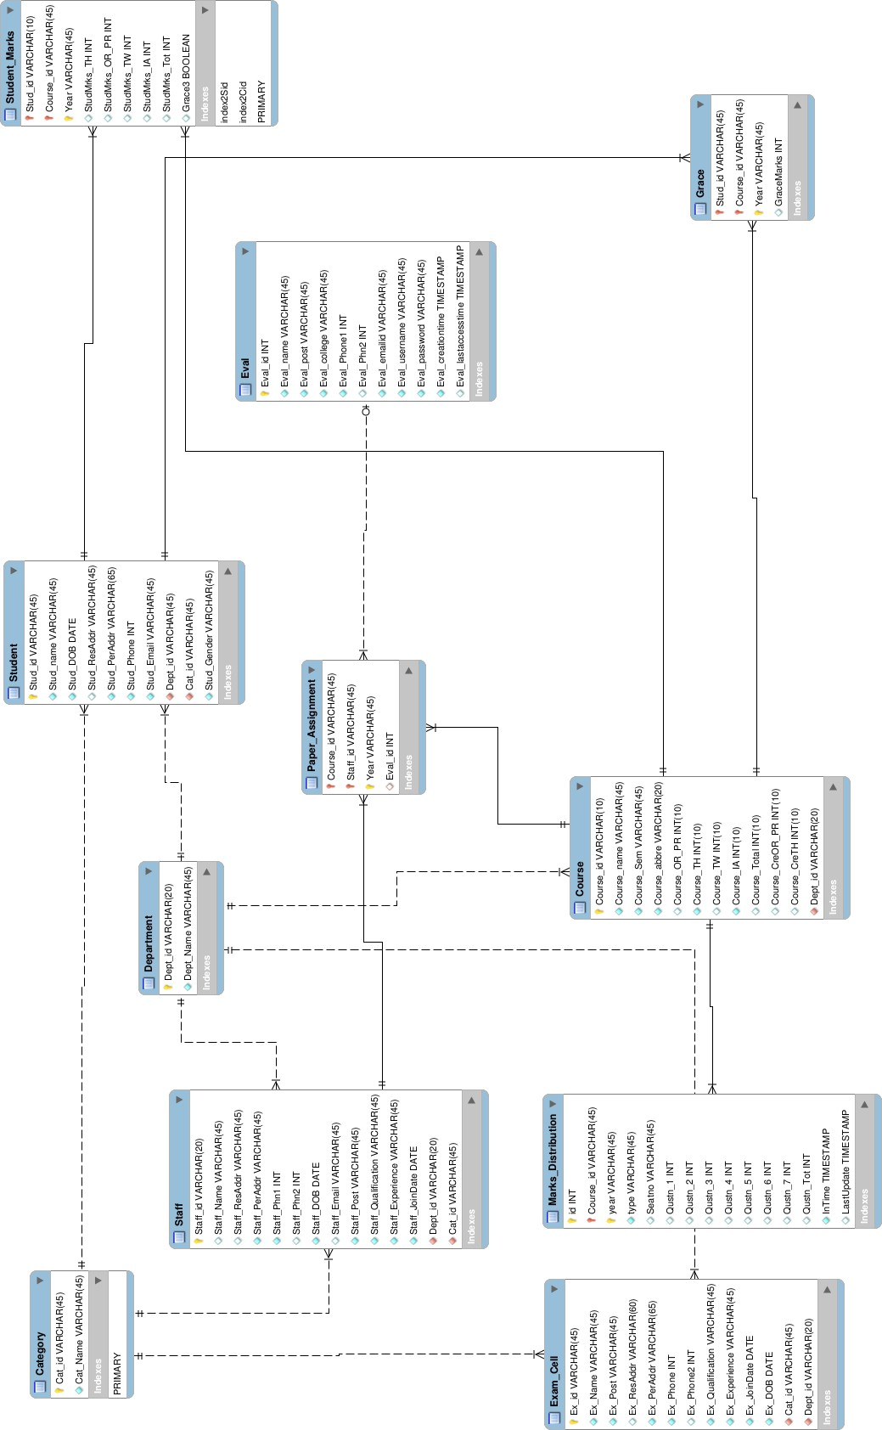

Figure 4.3: EER diagram

Chapter 4. System Design and Architecture

## Data Flow Diagrams

### Level 0 DFD

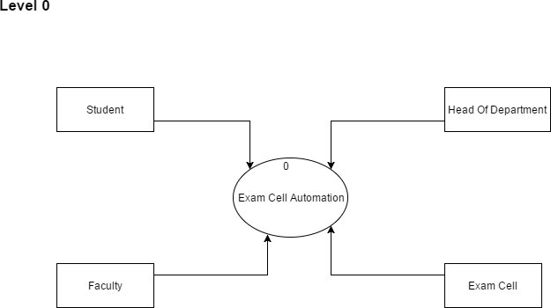

Figure 4.4: DFD Level 0

* 1. Data Flow Diagrams

### Level 1 DFD

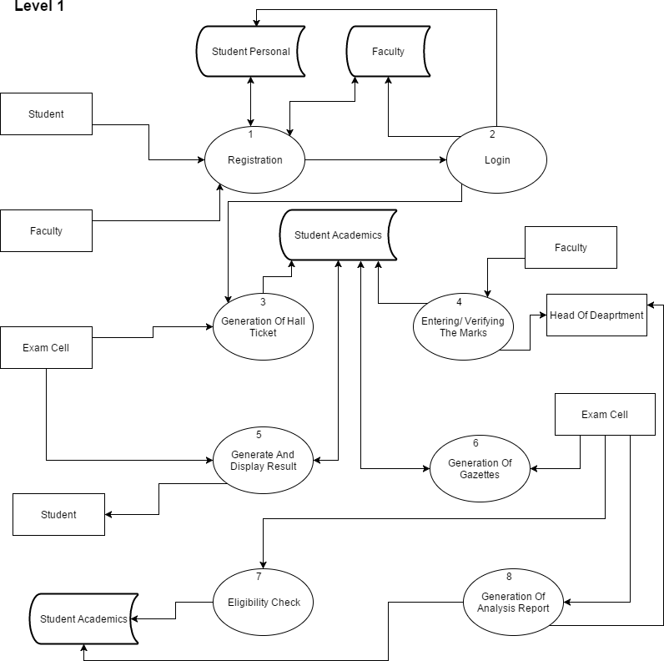

Figure 4.5: DFD Level 1

Chapter 4. System Design and Architecture

### Level 2 DFD

#### Level 2.1

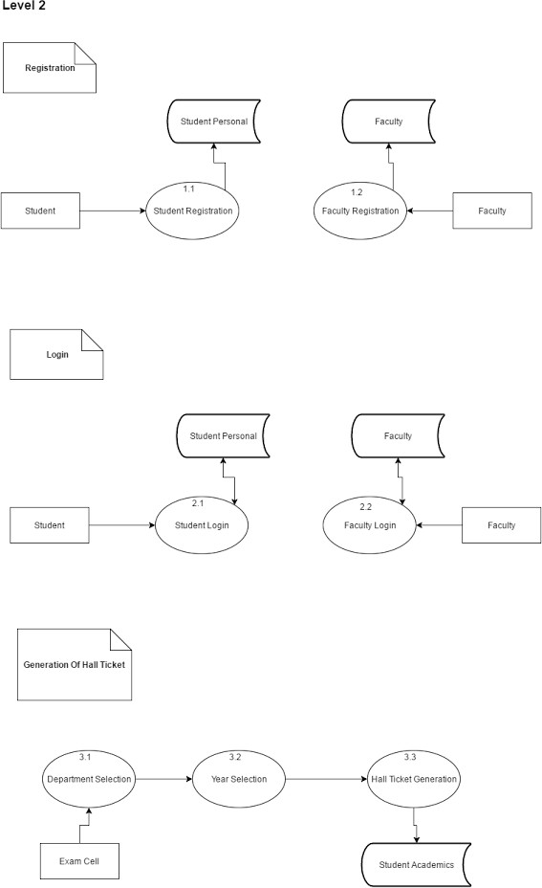

Figure 4.6: DFD Level 2.1

4.4. Data Flow Diagrams

#### Level 2.2

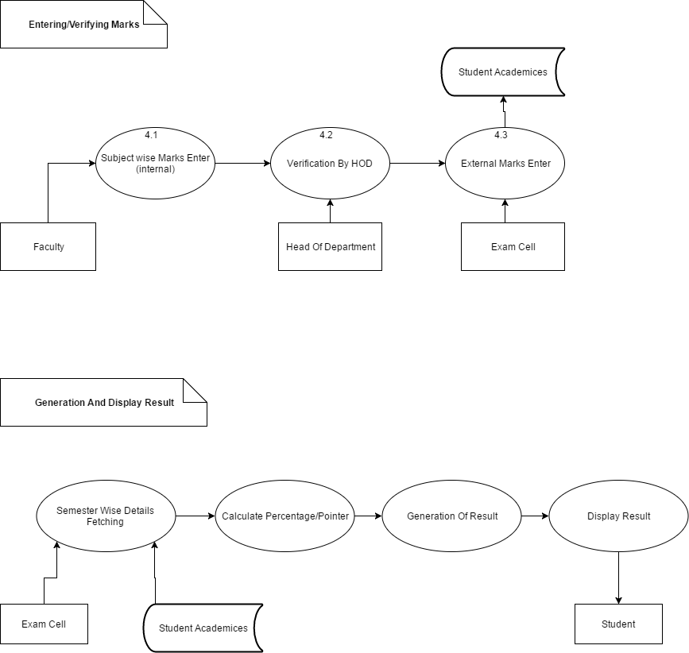

Figure 4.7: DFD Level 2.2

Chapter 4. System Design and Architecture

## Component Diagram

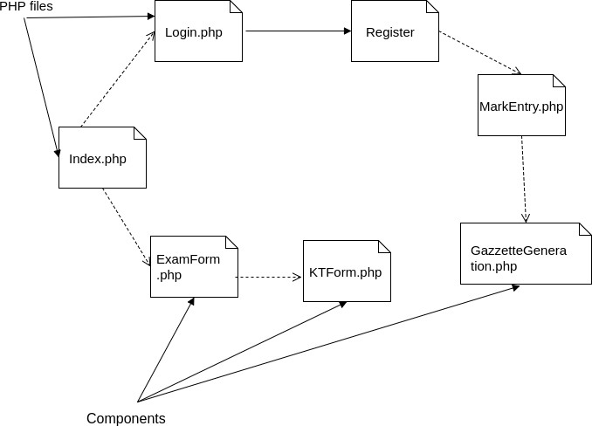

Figure 4.8: Component Diagram

# Chapter 5 Methodology

## ExamFlex (Exam Cell Automation System)

The students and the faculties will be registered first followed by the collection of information about the students and the respective faculty members along with the exam-cell staff members. The system will generate the hall tickets, results and also the mark sheets for the students. If the student has any k.t., the k.t. form will be generated for the students, same as for revaluation. The marks will be entered by the exam-cell staff as well as by the faculty members. The system will detect if the student is eligible or not so will generate its respective hall tickets. The system will also allow the students to view their results from any remote access, print their hall-tickets for which they need not to stand in long queues and make the process tedious.

This system will allow the students to access the exam form, k.t. form generated automatically, remotely. The processes will be automated by implementing this system and the workload will be reduced to a great extent. The system will also generate the gazette copies for the student’s results needed by the university through which the efficiency of the exam cell process will be increased, as there won’t be any need to use multiple software. In this system, input will be the marks of the students of their theory exams, practical exams, internal assessment and term work. Grades and pointers of student can be calculated according to rules, formulae and ordinances. Our system is divided into various modules 1. Login Module 2. Generation of Exam Form/ K,T. Form 3. Generation of Results 4. Generation of Gazette Copies

Chapter 5. Methodology

### Module 1: Login

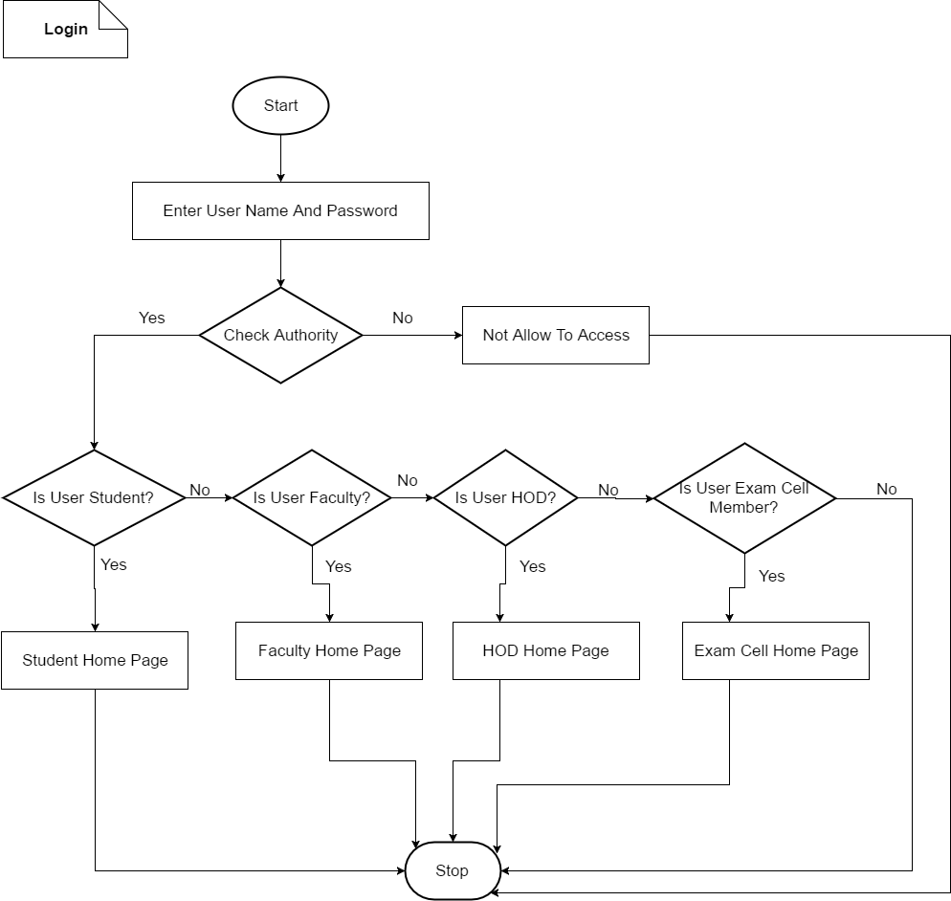

Figure 5.1: Flowchart: Login Process

The Login module of the system is the initial stage of the system. It will check for the valid registered users. If the usernames and passwords match, the system will identify the type of user whether its a student, faculty or some other. Based on the verification and identification process the system will redirect the users to their respective homepages.

5.1. ExamFlex (Exam Cell Automation System)

### Module 2: Generation of Exam Form

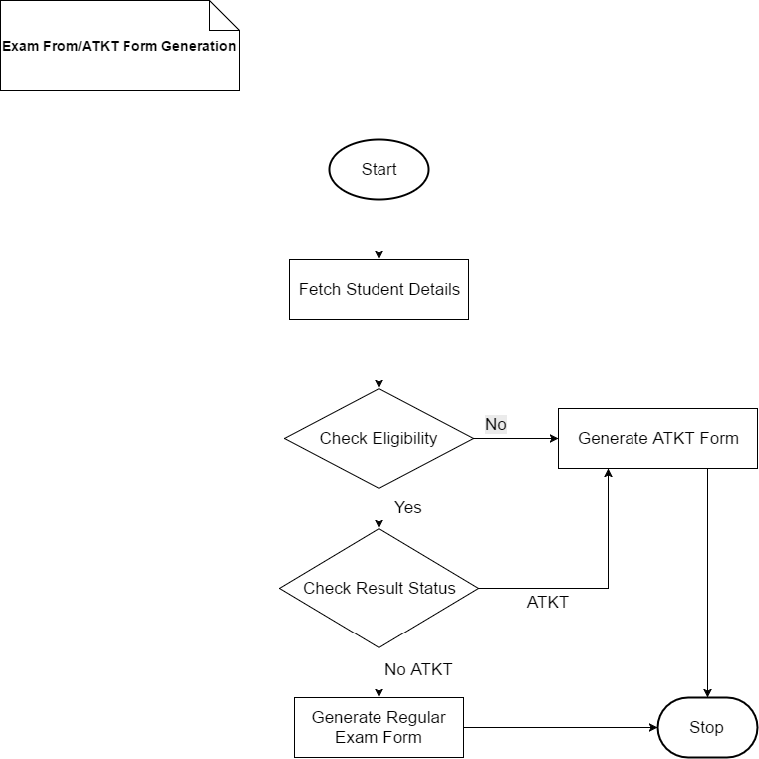

Figure 5.2: Flowchart for Generation of Exam Form/K.T. Form

The generation of Exam Forms or the K.T. Forms will depend upon the eligibility criteria and the result status for the student. If the student is eligible for the current semester, a regular form will be automatically generated whereas if the student is not eligible for current examination, a

K.T. form wil be generated. However, if a student is eligible for the current semester but also has k.t. in previous semesters, both the Regular Exam Form as well as the K.T. Form will be generated.

Chapter 5. Methodology

### Module 3: Generation of Result

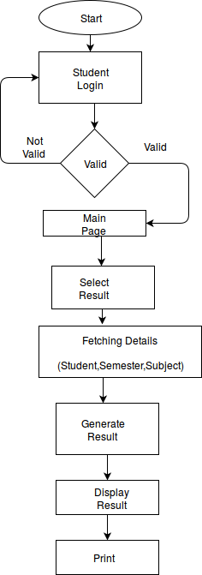

Figure 5.3: Flowchart on Generation of Results

The logged in student after the examinations doesn’t need to stand in long queues for the col- lection of the result. The student need to select the option for the Result, where the system will fetch all the required details for the particular student, the department, the semester, the marks, which will be filled in a standard mark sheet format along with calculated percentage and SGPI/CGPI.

* 1. ExamFlex (Exam Cell Automation System)

### Module 4: Generation of Gazette

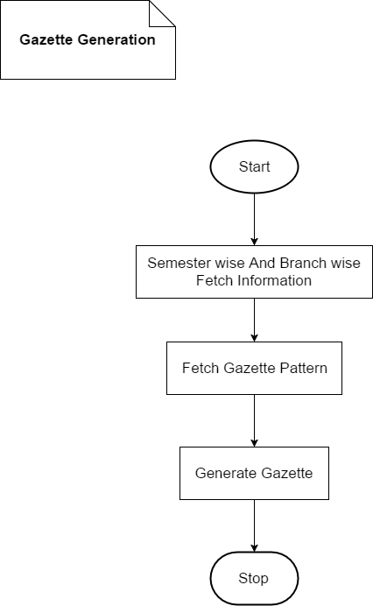

Figure 5.4: Flowchart on Generation of Gazette Copies

Chapter 5. Methodology

Gazette is a standard format document which is needed by the Mumbai University to store the details of the students. It has a particular format which has to be followed. After the examinations are conducted, the marks are entered in the system database, the system will fetch the student records, their marks along with the information about their department, the semester and also the format of the gazette. The system will produce gazettes for the University of Mumbai containing information about the students.

## Sequence Diagrams

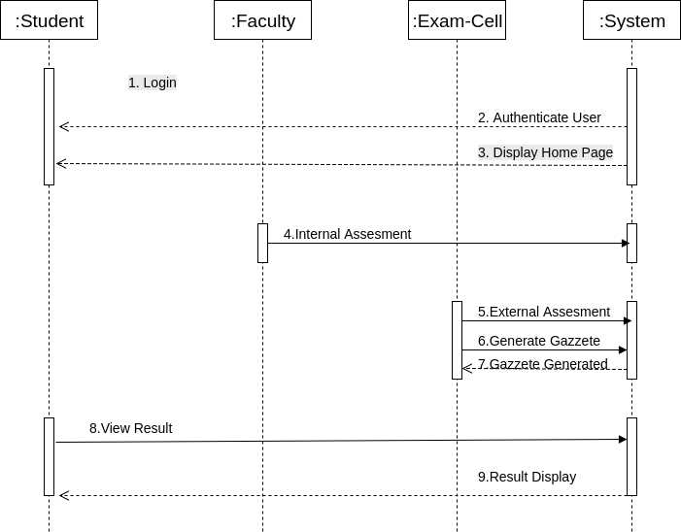

Figure 5.5: Sequence Diagram 1

* 1. Sequence Diagrams

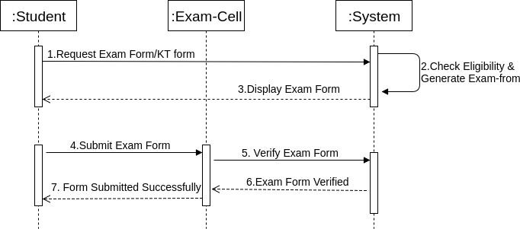

Figure 5.6: Sequence Diagram 2

Chapter 5. Methodology

## Activity Diagram

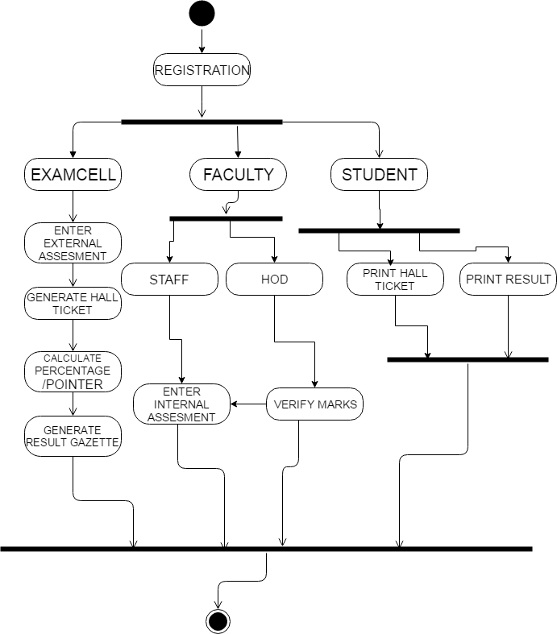

Figure 5.7: Activity Diagram

# Chapter 6 Implementation Details

## Assumptions And Dependencies

### Assumptions

1. We assume that using an effective web page will increase the flexibility of usage.
2. Students and faculties must be given an introduction on the functions performed by the system.

### Dependencies

1. Internet connection is required.

## Implementation Methodologies

The system is mainly dependent on the working done using PHP and mySQL for the database. The required items are fetched from the database such as the the student details along with his/her department/class/roll-no./marks and the result is then calculated. The exam cell staff has the authority to enter only the student theory marks, all the other respective marks are entered by the the subject teacher himself/herself. Once the users are logged in, they are provided with certain privileges which are restricted to the category they belong. The conditions and the restrictions are put with the help of PHP language. The UI pages are developed with the help of a framework named Bootstrap. For the generation of Gazette, an algorithm is developed, which checks the conditions, the marks, and calculates respective grades; with the help of which it calculates the final result in the terms of index pointers (SGPI CGPI).

# Chapter 7 Results and Analysis

## Test cases and Result

#### Login:

**Input Login Test:** Wrong Username Password

**Output Login Test:** Message displayed: Incorrect Username/Password

**Error:** No Error Found

**Input Login Test:** Right Username Password **Output Login Test:** Logged in Succesfully **Error:** No Error Found

#### Gazette Generation:

**Input test:** Marks less than Minimum

**Output test:** Denoted by ’F’

**Error:** No Error Found

**Input test:** Generate PDF

**Output test:** No Operation

**Error:** Error found: Irresponsive function

It contains the result of output of your project. The output can be numeric or graphical based. Represent or write down the results in tabular form if applicable and analyze that by using graphs or charts. Also make a comparison of your work with the existing one(s).

7.2. Analytical Discussion

## Analytical Discussion

### System Output

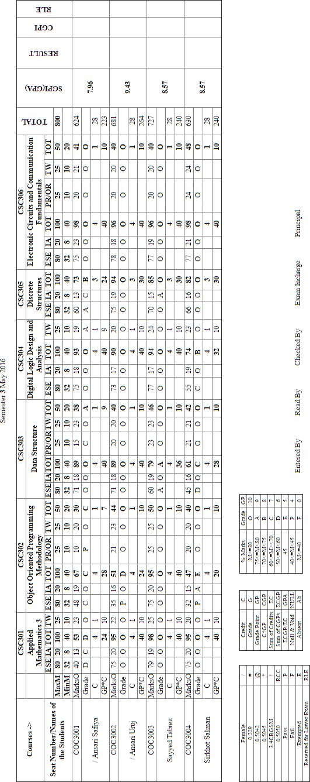

Figure 7.1: Gazette Output 1

In the above figure, according to the class selected the results of the respective students are calculated and displayed. A limit of 4 students is applied for a single copy.

Chapter 7. Results and Analysis

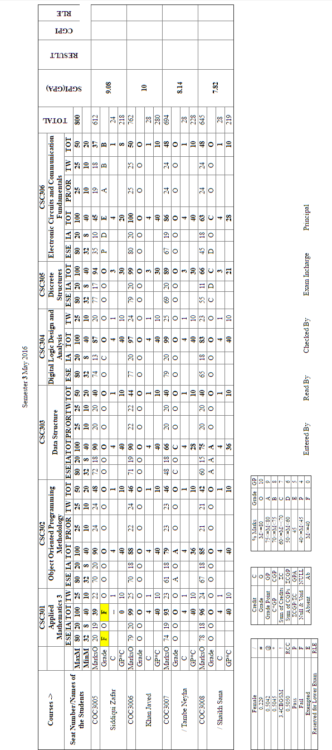

Figure 7.2: Gazette Output 2

In the above figure, according to the results, the failed students will be highlighted by the system automatically and thus the exam cell staff doesn’t need to search for the failed students.

7.2. Analytical Discussion

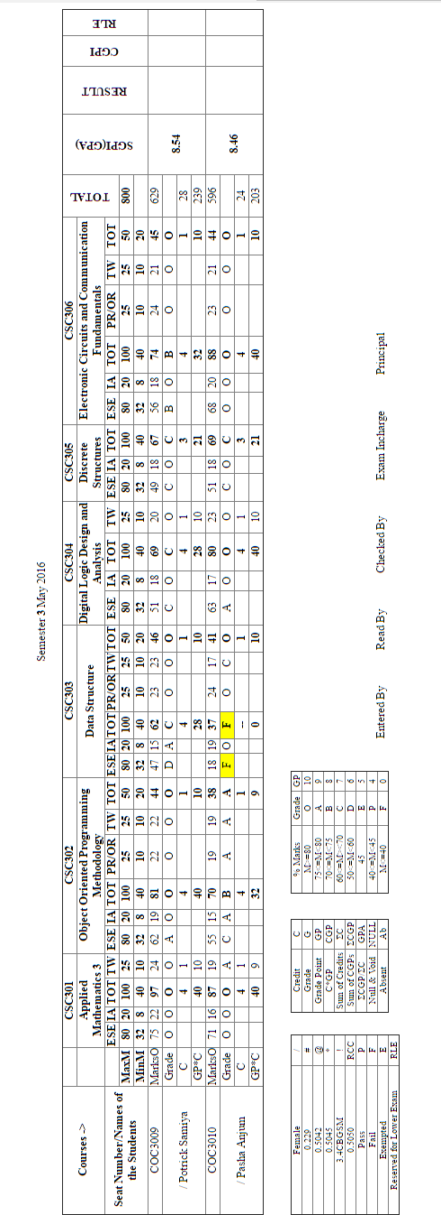

Figure 7.3: Gazette Output 3

In the above figure, as per the strength of the class, the system will generate the gazette. Last page of all the gazettes generated are shown in the figure.

# Chapter 8 Conclusion and Future Scope

## Conclusion

Ultimately the result of the implementation of this project will lead to reduce the workload of the students, the faculty members and the exam-cell staff. The result would be a fully-fledged working Automated Examination Process System. Apart from this the students will be able to view their results, their academic status on the system itself. The faculty members will be able to enter the marks for respective subjects for the students. The Exam-cell staff will be able to enter the external examination marks of the students.

The Head of the department will be able to monitor the status of the students as well the marks verification and validation for the students will be done by the head of department. There won’t be any need to use multiple different systems for different activities. The processes will be covered by the proposed system. This will reduce the tediousness of the manual processes and give a chance for efficient, flexible and automated processes.

## Limitations

For now, the system is limited to a single department of an engineering institute. The system will not work if the internet connection is down.

## Future Enhancement

8.3. Future Enhancement

As the technologies are emerging, it is possible to enhance the system and make it adaptable to desired environment i.e. customize as per the college requirements. For security issues, a technology known as QR Code could be implemented. Using which, the results, databases could be digitalized saving a lot of space and providing faster access.

As per the requirements of the University/College, further changes could be implemented in the system making it more reliable, more efficient and convenient for everybody to use it.

# References

1. XamClick Exam Cell Automation System by Harsha Khutafale, Hardika Mate, Vaishnavi Sabnawis, Prof. Nilesh Patil, International Journal of Advanced Research in Computer Science and Software Engineering-2016
2. Exam-Cell Automation System: Nevonprojects.com
3. Automated Examination Support System by Bondre Rutuja Avinash, Durgi Varsha Vijayku- mar, Mohite Pradnesh Rajeev, Parkar Vishal V, International Journal of Current Engineering and Technology-2015
4. VIVA Gazette Generator: VIVA College
5. KHUSHI: Exam Cell Automation System
6. Sanket Mandare, Tyagraj Sonawane, Aman Trivedi, K. T. V. Reddy *PDF Marksheet Gener- ator: I.J. Information Technology and Computer Science, 2014*
7. Somdip Dey *New Generation of Digital Academic-Transcripts using encrypted QR Code: IEEE*
8. Prof. D. V. Shinkar *QR code Authentication System for confidential(digital Mark sheet) Encrypted data hiding and retrieval (Decryption): International Journal of Advanced Research in Computer and Communication Engineering*
9. Trisha Chatterjee, Tamodeep Das, Joyshree Nath, Shayan Dey, AsokeNath *Symmetric key cryptosystem using combined cryptographicalgorithms - Generalized modified Vernam Cipher method, MSAmethod and NJJSAA method: TTJSA algorithmâ: Proceedings of Information and Communication Technologies (WICT)*
10. Suraj Kumar Sahu, Sandeep Kumar Gonnade *QR Code and Application in India: Interna- tional Journal of Recent Technology and Engineering (IJRTE)*
11. John Enderle, Nicholas Noyes, Abdullah A. AlAqeel *Custom report generator: IEEE 26th Annual Bioengineering Conference,2000*

8.3. Future Enhancement

1. Mital Doshi *A predictive model for effective higher education: IEEE 2013 International*

# Chapter 9 Appendix A

## SGPI/CGPI Calculation

Semester Grade Performance Index (SGPI): The performance of semester is indicated by a number called semester grade performance index. SGPI is the weighted average of the grade points obtained in all the courses by the student during the semester.

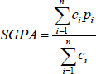

Figure 9.1: SGPA Formula

Cumulative Grade Performance Index (CGPI): An up to date of an overall performance of student from the time he/she enrolled in the university is obtained by calculating a number called cumulative grade performance index. It is calculated in similar manner of SGPI. CGPI is responsible to reflect final pass or fail status of student.

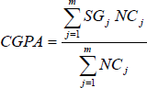

Figure 9.2: CGPA Formula

9.2. Mumbai University Grading System

## Mumbai University Grading System

|  |  |  |  |
| --- | --- | --- | --- |
| Percentage of  Marks Obtained | Letter  Grade | Grade  Point | Performance |
| 80.00 and Above | O | 10 | Outstanding |
| 75.00-79.99 | A | 9 | Excellent |
| 70-74.99 | B | 8 | Very Good |
| 60.00-69.99 | C | 7 | Good |
| 50.00-59.99 | D | 6 | Fair |
| 45.00-49.99 | E | 5 | Average |
| 40.00-44.99 | P | 4 | Pass |
| Less Than 40.00 | F | 0 | Fail |

Table 9.1: Letter Grades with respective Grade Points

## CGPI Equivalent Marks

|  |  |
| --- | --- |
| CGPI | Equivalent Percentage  Marks |
| 6.75 | 60% |
| 7.25 | 65% |
| 7.75 | 70% |
| 8.25 | 75% |

Table 9.2: CGPI Grading System

# ACKNOWLEDGMENT

We would like to take the opportunity to express our sincere thanks to our guide **Tabrez Khan**, Professor, Department of Computer Engineering, AIKTC, School of Engineering, Panvel for his invaluable support and guidance throughout our project research work. Without his kind guidance & support this was not possible.

We are grateful to him for his timely feedback which helped us track and schedule the process effec- tively. His time, ideas and encouragement that he gave helped us to complete our project efficiently. We would also like to thank **Dr. Abdul Razak Honnutagi**, AIKTC, Panvel, for his encouragement and for providing an outstanding academic environment, also for providing the adequate facilities. We are thankful to **Prof. Tabrez Khan**, HOD, Department of Computer Engineering, AIKTC, School of Engineering, Panvel and all my B.E. teachers for providing advice and valuable guidance. We also extend our sincere thanks to all the faculty members and the non-teaching staff and friends for their cooperation.

Last but not the least, we are thankful to all our family members whose constant support and encourage- ment in every aspect helped us to complete our project.

**Ansari Safiya Nizamuddin Rehana Ansari Uruj Abdul Hadi Rukhsana**

Roll No: 12CO02 Roll No: 14DCO52

B.E. (Computer Engineering) B.E. (Computer Engineering)

University of Mumbai. University of Mumbai.

**Sayyed Tabrez Naushad Ahmed Anisa Sirkhot Salman Sadique Nazli**

Roll No: 14DCO63 Roll No: 14DCO68

B.E. (Computer Engineering) B.E. (Computer Engineering)

University of Mumbai. University of Mumbai.